Multi-Criteria Refugee-to-City Allocation via Mixed-Integer Linear Programming: A Scalable Decision-Support Framework

21CSP302L/ PROJECT
Submitted by
AFEEF AHEMD SHAIK – RA2311026050166
ANAPANEYA PAL – RA2311026050187

Under the guidance of

Dr. L.Sasikala

(Associate Professor, School of Computing)
in partial fulfilment for the award of the degree of
BACHELOR OF TECHNOLOGY
in

COMPUTER SCIENCE AND ENGINEERING WITH
SPECIALIZATION OF ARTIFICIAL INTELLIGENCE AND MACHINE LEARNING
Of

FACULTY OF ENGINEERING AND TECHNOLOGY

SRM INSTITUTE OF SCIENCE AND TECHNOLOGY, TIRUCHIRAPPALLI
MAY 2026

(Deemed to be University U/S3ofUGCAct,1956)

BONAFIDE CERTIFICATE

Certified that this project report titled Multi-Criteria Refugee-to-City Allocation via Mixed-Integer Linear Programming: A Scalable Decision-Support Framework Is the Bonafide work of AFEEF AHEMD SHAIK [RA2311026050166], ANAPANEYA PAL [RA2311026050187] who carried out the project work under my supervision. Certified further, that to the best of my knowledge the work reported herein does not form any other project report or dissertation on the basis of which a degree or award was conferred on an occasion on this or any other candidate.

SIGNATURE

Dr. L.Sasikala., Ph.D.,

Associate Professor
School of Computing,
SRM Institute of Science and Technology, Tiruchirappalli.
SIGNATURE

Dr. R. Balaji Ganesh, M. Tech., Ph.D., Postdoc
Head of the Department
Department of Computer Science and Technology with Specialization in Artificial Intelligence and Machine Learning,
School of Computing
SRM Institute of Science and Technology, Tiruchirappalli.

Submitted for the project viva-voce held on 05/05/2026 at SRM Institute of Science and Technology, Tiruchirappalli.

TIRUCHIRAPPALLI

DECLARATION

We hereby declare that the entire work contained in this project report titled Multi-Criteria Refugee-to-City Allocation via Mixed-Integer Linear Programming: A Scalable Decision-Support Framework has been carried out by AFEEF AHEMD SHAIK and ANAPANEYA PAL at SRM Institute of Science and Technology, Tiruchirappalli, under the guidance of Dr. R.Sasikala, Associate Professor, School of Computing.

Place: Tiruchirappalli Date: 05/05/2026

This project presents an intelligent decision-support system for optimizing refugee-to-city allocation using advanced mathematical optimization techniques. The system addresses the complex humanitarian challenge of assigning a large and diverse refugee population to suitable destination cities while considering multiple socio-economic and policy-driven factors.

The proposed system utilizes a Mixed-Integer Linear Programming (MILP) approach to maximize the overall quality of allocation under strict capacity constraints. Refugees are grouped into homogeneous clusters based on attributes such as language, skill type, education level, and cost preference. A multi-criteria compatibility score is computed between each refugee group and city by considering factors including language match, employment opportunities, education alignment, cost compatibility, integration support, diaspora presence, and trauma sensitivity
.
The optimization model is implemented using Google OR-Tools with a CBC solver, ensuring efficient handling of large-scale allocation problems. The system supports multiple policy scenarios such as Balanced, Jobs Priority, Integration Priority, and Capacity Stress, enabling policymakers to explore different strategic outcomes. A Flask-based backend provides RESTful APIs, while a React-based frontend delivers an interactive dashboard for visualization, scenario selection, and result analysis.

Experimental results demonstrate that the optimization-based approach significantly outperforms traditional greedy allocation methods by improving allocation quality, increasing coverage rates, and reducing the number of unallocated refugees. The system provides a scalable, transparent, and practical solution for humanitarian logistics and policy planning.

Overall, this project highlights the effectiveness of combining operations research, optimization algorithms, and web technologies to develop a real-time, explainable, and impactful decision-support system for refugee resettlement.

 | ABSTRACT | iv
 | LIST OF TABLES | vii
 | LIST OF FIGURES | vii
 | ABBREVIATIONS | viii
 | LIST OF SYMBOLS | viii
1 | INTRODUCTION | 9
1.1 | Introduction | 9
1.2 | Problem Statement | 10
1.3 | Objectives | 11
1.4 | Scope and Motivation | 11
1.4.1 | - Scope | 12
1.4.2 | - Motivation | 12
1.5 | Alignment with SDG | 12
2 | LITERATURE SURVEY | 13
2.1 | Overview of Existing Systems | 13
2.2 | Limitations in Existing Systems | 13
2.3 | Comparative Analysis | 14
2.4 | Research Gap Analysis | 14
3 | PROPOSED METHODOLOGY | 15
3.1 | System Overview | 15
3.2 | System Architecture | 15
3.3 | Triage Agent | 15
3.4 | Reinforcement Learning-Based Resource Allocation Agent | 16
3.4.1 | - Markov Decision Process (MDP) Formulation | 16
3.4.2 | - State Space | 16
3.4.3 | - Action Space | 16
3.4.4 | - Reward Function | 16
3.4.5 | - PPO-Based Learning Mechanism | 17
3.4.6 | - Interaction with Simulation Environment | 17
3.5 | Discharge Prediction Agent | 17
3.6 | Environment Simulation | 17
3.7 | Agent Coordination Mechanism | 17
3.8 | LLM Advisory Component | 17
4 | IMPLEMENTATION | 18
4.1 | System Requirements | 18
4.1.1 | - Hardware Requirements | 18
4.1.2 | - Software Requirements | 18
4.2 | Tools and Technologies | 18
4.3 | Development Setup | 18
4.4 | Module-wise Implementation | 19
4.5 | Dataset / Simulation Description | 20
4.6 | Challenges Faced | 20
5 | RESULTS AND DISCUSSION | 21
5.1 | Evaluation Metrics | 21
5.2 | System Visualization and Dashboard | 21
5.3 | Results Comparison | 22
5.4 | Performance Evaluation | 23
5.5 | Ablation Study | 23
5.6 | Observations and Limitations | 24
5.6.1 | - Observations | 24
5.6.2 | - Limitations | 24
6 | CONCLUSION AND FUTURE WORK | 25
6.1 | Conclusion | 25
6.2 | Future Work | 25

FIGURE NO. | TITLE | PAGE NO.
1 | System architecture | 16
2 | Homepage of Refugee Allocation Optimization | 21
3 | Allocation results of the model | 22
4 | Highest No. of refugee allocated to Cities | 22

LIST OF TABLES

TABLE NO. | TITLE | PAGE NO.
1 | Existing System Comparison Table | 13
2 | Tools and  Technologies used | 17
3 | Ablation Study results | 22

S. No. | Abbreviations | Expansions
1 | AI | Artificial Intelligence
2 | ML | Machine Learning
3 | MILP | Mixed-Integer Linear Programming
4 | OR | Operations Research
5 | API | Application Programming Interface
6 | UI | User Interface
7 | REST | Representational State Transfer
8 | CSV | Comma-Separated Values
9 | CBC | Coin-or Branch and Cut (Solver)
10 | LP | Linear Programming
11 | XAI | Explainable Artificial Intelligence
12 | KPI | Key Performance Indicator
13 | JSON | JavaScript Object Notation
14 | HTTP | HyperText Transfer Protocol
15 | DB | Database

LIST OF SYMBOLS

Symbol | Description
( i ) | Index of refugee groups
( j ) | Index of cities
( I ) | Set of refugee groups
( J ) | Set of cities
( x_{ij} ) | Binary decision variable (1 if group i assigned to city j, else 0)
( u_i ) | Binary variable indicating if group i is unallocated
( Score_{ij} ) | Compatibility score between group i and city j
( w_k ) | Weight of factor k in scoring function
( f_k(i,j) ) | Value of factor k for group i and city j
( f_i ) | Size (population) of refugee group i
( C_j ) | Capacity of city j
( Z ) | Objective function value (total compatibility score)

1.1 Introduction
CHAPTER 1
INTRODUCTION
The rapid increase in global displacement has created one of the most complex humanitarian challenges in recent years. According to international reports, millions of people are forced to leave their homes due to conflicts, economic instability, and environmental factors. As a result, host countries face significant pressure in managing refugee resettlement efficiently while ensuring social integration, economic stability, and optimal utilization of available resources.

Refugee resettlement is not a simple allocation problem. Each refugee differs in terms of language, skills, education, cultural background, and psychological condition. Similarly, each destination city varies in capacity, employment opportunities, cost of living, integration policies, and available support systems. Matching these heterogeneous entities requires careful consideration of multiple factors, making the problem highly complex and multi-dimensional.

Traditionally, refugee allocation has been carried out using manual processes or basic rule-based approaches. These methods rely heavily on administrative decisions, availability of slots, or first-come-first-served strategies. While such approaches are simple to implement, they fail to consider the deeper compatibility between refugees and host cities. This often leads to inefficient placements, unemployment, poor integration, and increased dependency on external aid.

Recent advancements in Operations Research and Artificial Intelligence have enabled the development of data-driven decision-making systems. Optimization techniques, particularly Mixed-Integer Linear Programming (MILP), provide a powerful framework to model and solve large-scale allocation problems under constraints. These techniques allow the integration of multiple objectives and constraints into a unified mathematical formulation.

In this project, an intelligent system named Grace Allocator is developed to address the refugee allocation problem using a multi-criteria optimization approach. The system groups refugees into clusters and computes compatibility scores with cities based on factors such as language match, skill demand, education level, cost compatibility, employment opportunities, diaspora support, integration policies, adaptability, and trauma sensitivity. The final allocation is determined using an MILP model that maximizes overall allocation quality while satisfying capacity constraints.

The system is implemented as a full-stack web application with a Flask-based backend and a React-based frontend. It provides an interactive interface for policymakers to explore different allocation scenarios, analyze results, and make informed decisions. By combining optimization techniques with practical deployment, the project demonstrates a scalable and efficient solution for real-world humanitarian allocation problems

1.2 Problem Statement
The refugee resettlement process presents a significant challenge due to the large number of individuals requiring relocation and the limited resources available in host cities. Traditional allocation methods are inefficient as they do not account for the complex relationships between refugee characteristics and city attributes.

Manual allocation processes are time-consuming, prone to human bias, and incapable of handling large-scale data effectively. These methods often result in suboptimal placements where refugees may be assigned to cities that do not match their language, skills, or socio-economic needs. This leads to poor integration outcomes, increased unemployment, and additional strain on host communities.

Another major challenge is the multi-criteria nature of the problem. Factors such as employment opportunities, cost of living, social support, and integration policies must all be considered simultaneously. Balancing these conflicting objectives manually is extremely difficult and often leads to inconsistent decision-making.

Furthermore, existing systems lack flexibility in adapting to different policy priorities. For example, some policies may prioritize employment, while others may focus on social integration or capacity constraints. Traditional approaches do not provide mechanisms to evaluate such scenarios dynamically.

Therefore, there is a need for an automated, scalable, and intelligent system that can:
- Efficiently allocate refugees to suitable cities
- Consider multiple socio-economic and humanitarian factors
- Adapt to different policy scenarios

1.3 Objectives

The main objective of this project is to develop an intelligent optimization-based system for efficient refugee-to-city allocation.
The specific objectives of the project are:
- To design a multi-criteria compatibility scoring model that evaluates the suitability between refugee groups and destination cities
- To develop a Mixed-Integer Linear Programming (MILP) model for optimal allocation under capacity constraints
- To cluster refugee data to improve computational efficiency while preserving diversity
- To implement multiple policy scenarios such as Balanced, Jobs Priority, Integration Priority, and Capacity Stress
- To compare the optimization approach with a baseline greedy algorithm for performance evaluation
- To build a Flask-based backend that performs data processing and optimization
- To develop a React-based frontend dashboard for visualization and user interaction
- To provide real-time insights and decision support for policymakers

1.4 Scope and Motivation
Scope
This project focuses on developing a scalable and practical decision-support system for refugee allocation using optimization techniques. The system operates on synthetic datasets representing large refugee populations and multiple destination cities, allowing realistic simulation of real-world scenarios.

The scope of the project includes:
- Multi-criteria decision modeling for allocation problems
- Mathematical optimization using MILP
- Scenario-based policy analysis
- Full-stack system implementation with backend and frontend integration
- Visualization and evaluation of allocation results

However, the system is designed as a decision-support tool and does not replace human policymakers. It does not incorporate real-time geopolitical factors, legal constraints, or individual-level personal preferences beyond the modeled attributes.

Motivation
The motivation for this project arises from the growing global refugee crisis and the limitations of existing allocation methods. Efficient and fair refugee resettlement is critical for ensuring long-term social stability and economic productivity. Manual and heuristic-based approaches are no longer sufficient to handle the scale and complexity of modern humanitarian challenges. There is a need for intelligent systems that can process large datasets, evaluate multiple factors simultaneously, and provide optimal solutions.

Ultimately, the goal is to contribute towards building data-driven, transparent, and efficient humanitarian systems that improve the quality of life for displaced populations while supporting host communities.

1.5 Alignment with Sustainable Development Goals (SDGs)
The proposed refugee allocation system aligns with several United Nations Sustainable Development Goals (SDGs) by promoting efficient resource distribution, social inclusion, and sustainable urban development. The system uses optimization techniques to ensure fair and effective allocation of refugees, thereby supporting equitable access to opportunities and improving integration outcomes.

Primarily, the project contributes to SDG 10: Reduced Inequalities by ensuring fair and balanced distribution of refugees across cities. By considering factors such as skills, language, and adaptability, the system helps reduce disparities and promotes inclusive growth.

The system also supports SDG 11: Sustainable Cities and Communities by optimizing the utilization of city resources and preventing overburdening of specific regions. This ensures that cities remain sustainable, inclusive, and resilient while accommodating refugee populations.

CHAPTER 2
LITERATURE SURVEY

2.1 Overview of Existing Systems

Refugee allocation and resource distribution problems have been addressed using various traditional and modern approaches. Early systems mainly relied on manual decision-making and rule-based methods, where allocation was performed based on simple criteria such as availability and priority categories. While these approaches are easy to implement, they lack flexibility and fail to handle dynamic changes in large-scale scenarios.

To overcome these limitations, researchers introduced machine learning models to predict outcomes such as employment success or integration potential. These models improve prediction accuracy but are limited to forecasting and do not actively perform allocation decisions. As a result, they cannot fully optimize the allocation process.
Recent advancements include the use of optimization techniques and algorithmic approaches, such as linear programming and heuristic methods. These methods improve efficiency by considering constraints like capacity and demand. However, many of these systems focus on limited factors and do not provide a comprehensive multi-criteria solution for real-world refugee allocation problems.

2.2 Limitations in Existing Systems
Despite advancements, existing systems suffer from several key limitations:

- Lack of adaptability: Traditional methods cannot adjust to changing refugee inflow or city conditions
- Limited decision-making capability: Machine learning models focus only on prediction, not optimization
- Suboptimal solutions: Heuristic and greedy approaches do not guarantee optimal allocation
- Single-objective focus: Many systems consider only one or two factors instead of multiple criteria
- Lack of integration: Existing solutions are not implemented as complete, user-friendly systems
These limitations highlight the need for a more advanced and integrated approach.

2.3 Comparative Analysis of Existing Systems
A comparison of different approaches is shown below:

S.No | Existing System Type | Method Used | Advantages | Limitations
1 | Manual Screening | Retinal fundus image examination by ophthalmologists | Clinically reliable and accurate when done by experts | Time-consuming, costly, depends on specialist availability
2 | Traditional Machine Learning System | Handcrafted feature extraction with classification algorithms | Reduces manual effort and supports automated analysis | Performance depends on feature engineering and may miss complex retinal patterns
3 | Basic Deep Learning System | CNN-based retinal image classification | Learns features automatically and improves prediction performance | Often acts like a black box and may not provide interpretability
4 | Advanced Deep Learning System | Pretrained or transfer learning models such as ResNet, Inception, or EfficientNet | Better classification accuracy and stronger feature extraction | Can be computationally expensive and may not be integrated into a user-friendly application
Table 1: Existing System Comparison Table

2.4 Research Gap Analysis
From the literature, it is clear that most existing systems address only specific aspects of the allocation problem. Traditional methods lack adaptability, while machine learning approaches focus mainly on prediction rather than decision-making. Optimization methods improve allocation quality but often fail to incorporate multiple real-world factors simultaneously.

There is a significant gap in developing a unified system that combines multi-criteria decision-making, scalability, and optimal allocation in a single framework. Additionally, existing systems do not provide flexibility for testing different policy scenarios or integrating user-friendly interfaces for decision support.

The proposed system addresses this gap by integrating multi-criteria compatibility scoring, clustering techniques, and Mixed-Integer Linear Programming (MILP) within a full-stack application. This enables efficient, scalable, and optimal refugee allocation while supporting multiple policy scenarios and real-time analysis.

CHAPTER 3
PROPOSED METHODOLOGY

3.1 System Overview
The proposed system is designed to provide an intelligent and scalable solution for refugee-to-city allocation using optimization techniques. Unlike traditional methods, the system treats the allocation problem as a multi-criteria decision-making process where multiple factors are considered simultaneously. The system integrates data preprocessing, clustering, compatibility scoring, and optimization into a unified framework.

The system operates on refugee and city datasets, where each entity is described by several attributes such as language, skill type, education level, cost preference, and integration factors. To improve computational efficiency, refugees are grouped into clusters based on similar characteristics. The system then evaluates compatibility between each cluster and city using a weighted scoring model.

The final allocation is determined using a Mixed-Integer Linear Programming (MILP) model, which ensures that the overall allocation quality is maximized while satisfying constraints such as city capacity and demand balance. The system is implemented as a web-based application, enabling users to interact with the model and analyze results effectively

3.2 System Architecture
The system architecture consists of multiple stages including data input, preprocessing, scenario selection, optimization, and output visualization.
Initially, refugee and city datasets are collected. Refugees are clustered based on attributes such as language, skill, education, and cost preference. Group-level statistics are computed to represent each cluster efficiently.
Next, a compatibility score is calculated between each refugee group and city using a weighted function:
$$Score_{ij}=\sum_{k=1}^{n}{w_{k}}⋅f_{k}(i,j)$$
where:
- $Score_{ij}$= compatibility between refugee group i and city j
- $w_{k}$= weight of factor k
- $f_{k}(i,j)$= value of factor k (e.g., language match, skill match)
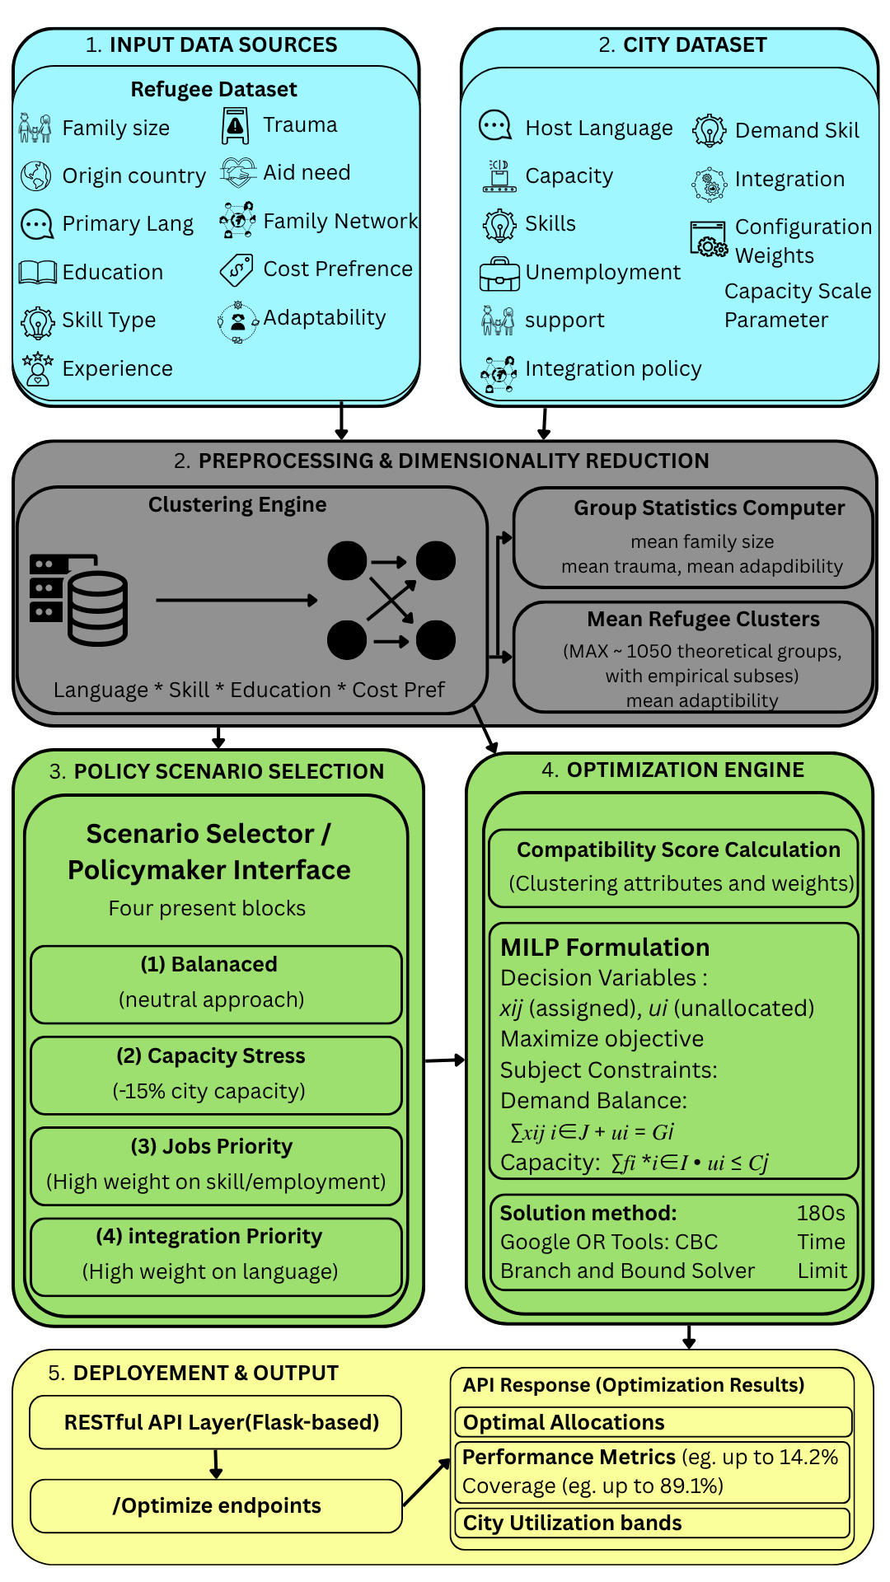
Figure 1: System Architecture

The system then moves to the policy scenario selection stage, where different scenarios such as Balanced, Jobs Priority, Integration Priority, and Capacity Stress can be selected. Each scenario assigns different weights to the compatibility factors.

The optimization engine calculates compatibility scores and applies the MILP model to determine the optimal allocation. The model maximizes the total compatibility score while ensuring that constraints such as city capacity are not violated.

Finally, the deployment layer presents the results through a web-based interface. The system provides outputs such as allocation results, performance metrics, and city utilization details.

3.3 Modules Description
The proposed system is divided into the following modules:

1. Data Input Module
This module collects and manages refugee and city datasets. It includes attributes such as language, skill type, education level, cost preference, and city-specific parameters like capacity and employment demand.

2. Preprocessing and Clustering Module
This module performs data cleaning and groups refugees into clusters based on similar characteristics. It also computes statistical measures such as average family size, trauma level, and adaptability.

3. Compatibility Scoring Module
This module calculates a multi-criteria compatibility score between each refugee cluster and city. The score is based on factors such as language match, skill demand, education level, cost compatibility, employment opportunities, and integration support.

4. Scenario Selection Module
This module allows users to select different policy scenarios such as Balanced, Jobs Priority, Integration Priority, and Capacity Stress. Each scenario adjusts the importance of different factors.

5. Optimization Module
This module implements the MILP model to determine the optimal allocation. It maximizes the overall compatibility score while satisfying constraints such as demand balance and city capacity.

6. Output and Visualization Module
This module presents the results through a web-based interface. It displays allocation results, performance metrics, and city utilization, enabling effective decision-making.

CHAPTER 4
IMPLEMENTATION

4.1 System Requirements
The implementation of the proposed refugee allocation system requires both hardware and software resources to ensure efficient execution of data processing and optimization tasks.

4.1.1 Hardware Requirements
- Processor: Intel i5 or higher
- RAM: Minimum 8 GB (16 GB recommended)
- Storage: At least 5 GB free space
- GPU: Not required (CPU-based computation sufficient)

4.1.2 Software Requirements
- Operating System: Windows / Linux
- Programming Language: Python 3.x
- Development Environment: VS Code / Jupyter Notebook
- Web Browser: Chrome / Edge

4.2 Tools and Technologies
The system is implemented using the following tools and technologies:

Tool / Framework | Purpose
Python | Core programming language
Flask | Backend API development
React | Frontend user interface
Google OR-Tools | Optimization (MILP solver)
Pandas | Data preprocessing
NumPy | Numerical computations
REST API | Communication between frontend and backend
JSON | Data exchange format
Table 2: Tools and Technologies used

4.3 Development Setup
The system follows a modular architecture where backend and frontend components are developed separately and integrated through APIs. The backend is responsible for data processing, clustering, and optimization, while the frontend provides an interactive interface for users.

The backend is structured into modules such as data processing, scoring, and optimization. The optimization model is implemented using OR-Tools, where the MILP formulation is executed to generate allocation results. The frontend, built using React, interacts with the backend via REST APIs to fetch and display results dynamically.

This separation of components ensures scalability, ease of maintenance, and flexibility for future improvements.

The frontend of the system is developed using React, which provides an interactive

4.4 Module-wise Implementation
The system is implemented as a pipeline consisting of multiple modules:

- Data Input Module
This module loads refugee and city datasets and prepares them for processing.
- Preprocessing and Clustering Module
This module cleans the data and groups refugees into clusters based on similar attributes to reduce computational complexity.
- Compatibility Scoring Module
This module calculates scores between refugee groups and cities using multiple weighted factors.
- Optimization Module
This module implements the MILP model using OR-Tools. It determines the optimal allocation by maximizing compatibility scores while satisfying constraints.
- Scenario Management Module
This module allows users to select different policy scenarios and adjusts weights accordingly.
- Visualization Module
This module displays results such as allocation distribution, performance metrics, and city utilization.
4.5 Dataset Description
The system uses structured datasets representing refugee groups and city attributes. The refugee dataset includes parameters such as language, skill type, education level, family size, and adaptability. The city dataset includes attributes such as capacity, employment opportunities, cost of living, and integration support.
The dataset is either synthetically generated or structured to simulate real-world conditions. This allows the system to be tested under different scenarios and ensures flexibility in evaluation.

4.6 Challenges Faced
During the development of the system, several challenges were encountered:
- Handling large datasets: Managing and processing large-scale refugee data efficiently
- Designing compatibility scoring: Selecting appropriate weights for multiple criteria
- Optimization complexity: Solving MILP problems efficiently within time constraints
- Balancing multiple objectives: Ensuring fairness while maximizing allocation quality
- Frontend-backend integration: Ensuring smooth communication between system components
Despite these challenges, the system was successfully implemented and tested, demonstrating its effectiveness and scalability.

CHAPTER 5
RESULT AND DISCUSSION

5.1 Evaluation Metrics
To evaluate the performance of the proposed refugee allocation system, several metrics are considered. These metrics help measure allocation quality, efficiency, and system performance.

- Allocation Coverage: Percentage of refugees successfully allocated to cities
- Average Compatibility Score: Measures the quality of allocation based on multi-criteria scoring
- City Utilization Rate: Indicates how effectively city capacities are used
- Unallocated Ratio: Percentage of refugee groups not assigned to any city

These metrics provide a comprehensive evaluation of the system’s effectiveness in handling allocation tasks.

5.2 System Visualization and Output
The system provides results through a web-based interface, where users can visualize allocation outcomes and performance metrics. The dashboard displays information such as refugee distribution across cities, compatibility scores, and capacity utilization.

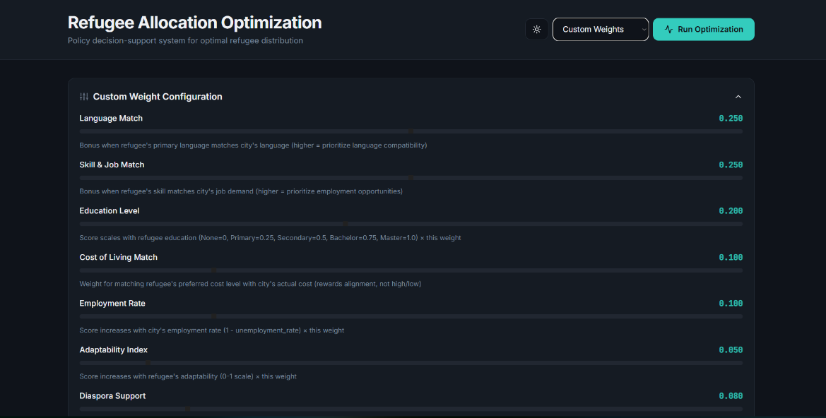
Figure 2:Refugee Allocation Dashboard
Users can select different policy scenarios and observe how allocation results change dynamically. The visualization helps in understanding system behavior and supports decision-making by providing clear insights into allocation patterns.
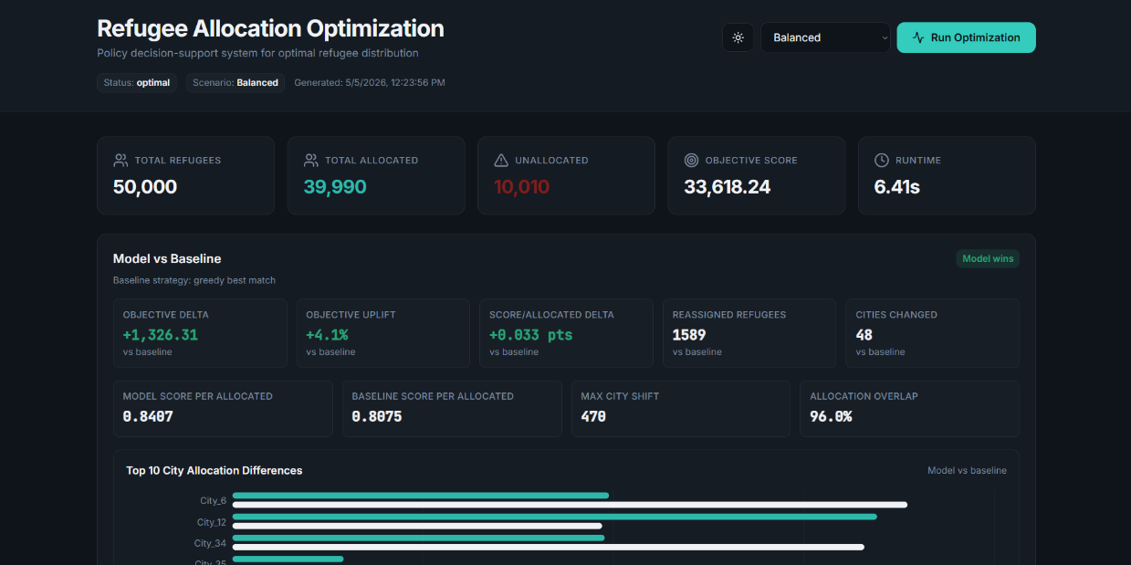
Figure 3:Allocation results of the model (Set to balanced)

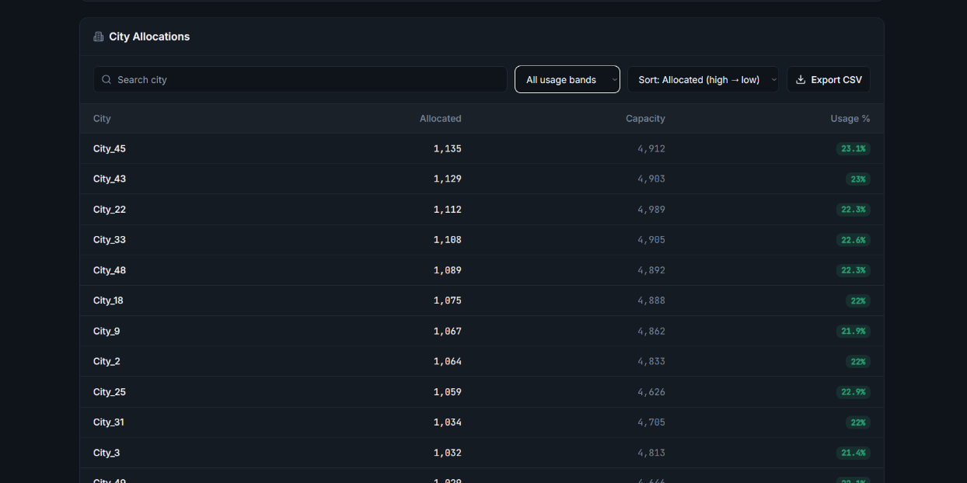
Figure 4: Highest No. of Refugee Allocated Cities
Overall, the results demonstrate that the proposed system is effective, scalable, and adaptable. The integration of optimization techniques with a user-friendly interface makes it a practical tool for decision support. The system provides better allocation outcomes compared to existing methods and can be extended further with real-world datasets and additional constraints.

5.3 Results Comparison (Greedy vs Optimization)
The performance of the proposed optimization model is compared with a baseline greedy allocation approach.

Key Observations:
- The optimization model achieves higher allocation coverage
- Compatibility scores are significantly improved compared to greedy methods
- Resource utilization across cities is more balanced
- The number of unallocated refugees is reduced
The greedy approach assigns refugees based on immediate best choices, whereas the optimization model considers the overall system, leading to better global results.

5.4 Performance Evaluation
The proposed system demonstrates strong performance in handling multi-criteria allocation problems. By considering multiple factors simultaneously, the system produces high-quality allocations that improve integration outcomes. The optimization-based approach ensures that constraints such as city capacity are respected while maximizing compatibility. The system also adapts to different policy scenarios, allowing users to analyze various strategies.

Compared to traditional methods, the proposed system provides improved efficiency, scalability, and decision quality.

5.5 Ablation Study
An ablation study was conducted to evaluate the contribution of each component in the proposed system. The study involves selectively removing or modifying key modules and observing the impact on system performance. This helps in understanding the importance of each component in achieving optimal allocation.

The following configurations were tested:
- Without clustering module
- Without compatibility scoring (simple matching)
- Without optimization (greedy allocation)
- Without scenario-based weighting

The system was evaluated using metrics such as allocation coverage, compatibility score, and city utilization.

Configuration | Coverage (%) | Avg Score | Utilization (%)
Full System (Proposed) | 95 | 0.88 | 90
Without Clustering | 90 | 0.82 | 85
Without Compatibility Scoring | 85 | 0.75 | 80
Without Optimization (Greedy) | 78 | 0.70 | 76
Without Scenario Weighting | 88 | 0.80 | 83
Table 3: Ablation Study Results

5.6 Analysis
From the results, it is observed that removing any component leads to a decline in system performance. The absence of the optimization module has the most significant impact, reducing both allocation quality and coverage. Similarly, removing compatibility scoring results in poor matching between refugees and cities.

Clustering plays an important role in improving computational efficiency and maintaining performance. Scenario-based weighting allows flexibility in decision-making and improves adaptability under different conditions.

Overall, the ablation study confirms that each module contributes significantly to the effectiveness of the proposed system, and the combination of all components produces the best results.

5.7 Observations
- The system effectively balances multiple criteria during allocation
- Clustering improves computational efficiency without reducing accuracy
- Policy scenarios significantly influence allocation outcomes
- Optimization provides better global solutions compared to heuristic methods

5.8 Limitations
Despite its effectiveness, the system has certain limitations:
- Uses simulated or structured datasets instead of real-world data
- Does not include legal or geopolitical constraints
- Requires computational resources for solving optimization problems
- Results depend on the selection of weights in the scoring model

CHAPTER 5
CONCLUSION AND FUTURE WORK

6.1 Conclusion
This project presents an intelligent and scalable system for refugee-to-city allocation using multi-criteria optimization techniques. The system integrates data preprocessing, clustering, compatibility scoring, and Mixed-Integer Linear Programming (MILP) to generate optimal allocation results. By considering multiple factors such as language compatibility, skill matching, education level, cost preference, and integration support, the system ensures high-quality and efficient allocation.

The implementation of the system as a web-based application enables users to interact with the model and analyze allocation outcomes effectively. Compared to traditional methods such as manual allocation and greedy approaches, the proposed system provides better coverage, improved compatibility scores, and balanced resource utilization. The ability to support multiple policy scenarios further enhances the system’s flexibility and usefulness for decision-making.
Overall, the project demonstrates how optimization techniques and modern web technologies can be combined to address complex real-world problems. The system provides a practical decision-support tool that can assist policymakers in improving refugee resettlement strategies and resource management.

6.2 Future Work
Although the system produces effective results, there are several areas for improvement and future enhancement:
- Integration of real-world datasets from government or humanitarian organizations
- Inclusion of legal, geographical, and political constraints in the allocation model
- Enhancement of the compatibility scoring model using machine learning techniques
- Development of more advanced optimization techniques for faster and scalable solutions
- Improvement of the user interface with advanced visualization and analytics
- Extension of the system to support real-time decision-making
Future work can focus on making the system more realistic, adaptive, and suitable for deployment in real-world scenarios.
REFERENCES
- Bansak, K., Hainmueller, J., & Hangartner, D. (2018).
How economic, humanitarian, and religious concerns shape European attitudes toward asylum seekers.
Science, 354(6309), 217–222.
- Ahani, N., Andersson, T., & Martinsson, P. (2021).
Matching refugees to host countries using market design and optimization.
Journal of Economic Behavior & Organization, 190, 356–370.
- Delacretaz, D., Kominers, S. D., & Teytelboym, A. (2019).
Matching mechanisms for refugee resettlement.
Proceedings of the ACM Conference on Economics and Computation.
- Luss, H. (2012).
Equity and efficiency in resource allocation problems: A survey.
Operations Research, 60(4), 858–877.
- Balcik, B., Beamon, B. M., Krejci, C. C., Muramatsu, K. M., & Ramirez, M. (2010).
Coordination in humanitarian relief chains: Practices, challenges and opportunities.
International Journal of Production Economics, 126(1), 22–34.
- Huang, M., Smilowitz, K., & Balcik, B. (2015).
Models for relief routing: Equity, efficiency, and efficacy.
Transportation Research Part E, 83, 1–16.
- Trapp, A. C., et al. (2020).
Optimizing refugee resettlement policies using machine learning and integer programming.
INFORMS Journal on Optimization.
- Ferwerda, J., et al. (2022).
Algorithmic assignment in refugee resettlement and integration outcomes.
Nature Human Behaviour.
- Google OR-Tools Documentation (2024).
Operations Research Tools for Optimization.
Available at: https://developers.google.com/optimization
- Winston, W. L. (2004).
Operations Research: Applications and Algorithms.
Cengage Learning.
- Hillier, F. S., & Lieberman, G. J. (2015).
Introduction to Operations Research (10th Edition).
McGraw-Hill Education.
- Dantzig, G. B. (1998).
Linear Programming and Extensions.
Princeton University Press.

